Condition Step

Objective

The AND logic operation returns true only if all of its inputs are true. If any of the inputs is false, the output is also false.

The OR logic operation returns true if any of its inputs are true. If all of the inputs are false, the output is also false.

Executes a block of statements if the specified condition is true; otherwise, the block of statements in the else clause is executed. Most programming languages have an if/else statement: to check to see if some expression is true and if it is do something, otherwise do something else.

UI

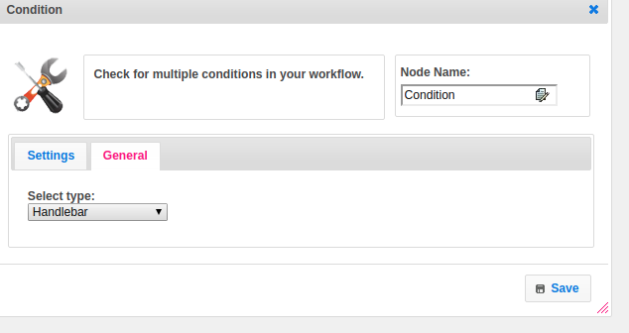

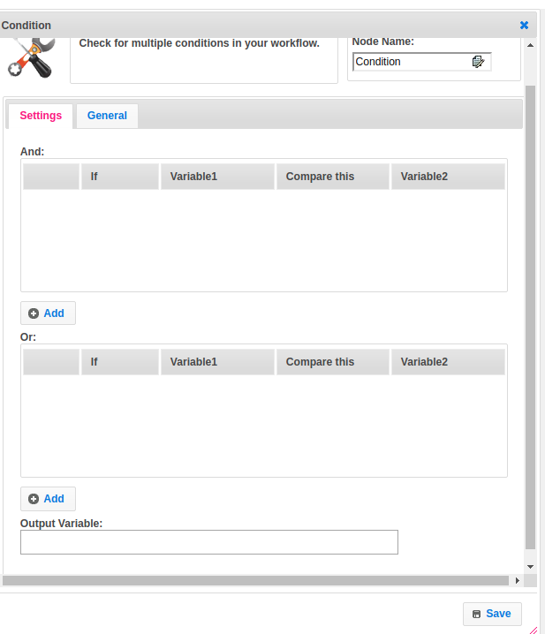

## Attributes

|  |  |
| --- | --- |
| **Attributes** | **Description** |
| **1. Select Type** | Value type used to set the value type.  Value types are two types.  1.hb-HandleBars  2.ftl-Freemarker Template Language. |
| **2. And** | List of multiple conditions.  The AND logic operation returns true only if all of its inputs are true. If any of the inputs is false, the output is also false. |
| **3. Or** | List of multiple conditions.  The OR logic operation returns true if any of its inputs are true. If all of the inputs are false, the output is also false. |
| **4. Output Variable** | Used to store the response of the request. |

## Executor Description

Get a list of AND conditions and OR condition if they are not empty. Check the conditions of each list. In a list of AND conditions returns true if all of its inputs are true else it returns false. In a list of OR returns true if any of the input is true else it returns false.

## Resource

For more information please refer the following link.

<https://www.w3schools.com/java/java_operators.asp>